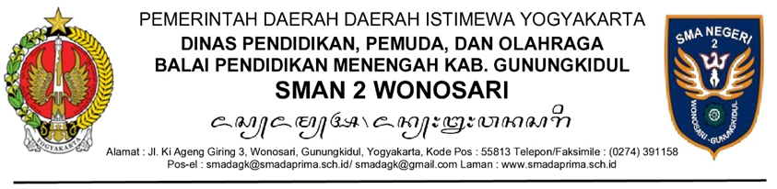

MEMORANDUM/MEMO

Yth. : ................................................................................................................
Hal : ................................................................................................................

........................................................................................................................................................................................................................................................................................................................................................
........................................................................................................................................................................................................................................................................................................................................................
........................................................................................................................................................................................................................................................................................................................................................

Tanggal, Bulan, Tahun
Kepala SMAN 2 Wonosari,

Drs. Tiya, M.M.

